## RESULTS

### Study Sample

In total, teams visited 448 households in the 13 health zones of Béboto district. Of those households, 48 (10.7%) required a second visit, either because the household was empty (n = 17, 3.8%), or there was no adult present who could consent to the interview (n = 31, 6.9%). In either case, teams returned later in the day to these households. Of households visited a second time, 8 (16.7%) were still empty and 19 (40.0%) still had no one who could consent.

Only one household did not consent to be interviewed because the head of household was absent. In addition, 75 (16.7%) households visited were not interviewed because they did not have any children of eligible age (6 months to 9 years).

In total, teams completed interviews with 321 households of the 448 households visited, giving a response rate of 73.9%.

|  |  |  |  |  |  |  |  |  |  |  |  |  |  |  |  |  |  |  |  |  |  |  |  |  |
| --- | --- | --- | --- | --- | --- | --- | --- | --- | --- | --- | --- | --- | --- | --- | --- | --- | --- | --- | --- | --- | --- | --- | --- | --- |
| Table 1. Characteristics of the households visited during the vaccination coverage survey for measles in Béboto district, Logone Oriental province, Chad   | Characteristic | Count (n) | Percent (%) | | --- | --- | --- | | Households visited | 448 | 100.0 | | Households interviewed | 321 | 73.9 | | Households requiring second visit | 48 | 10.7 | | Households empty (after 2nd visit) | 8 | 16.7 | | Households without adult (after 2nd visit) | 19 | 40.0 | | Households without eligible children | 75 | 16.7 | | Households that did not consent | 1 | 0.2 | |

### Demographic information:

We included 321 households across 31 clusters in this survey analysis, amounting to 985 children. The median number of children per household was 3 (range: 1–10, standard deviation: 1.6).

Among the 985 surveyed individuals, there were 470 (47.7%) females and 515 (52.3%) males (unweighted). The median age of surveyed individuals was five years (Q1-Q3 of 3-8 years), with 401 children under five years of age (40.7%).

Among survey respondents, the median age was 32 years, and the majority self-identified as either the father or the mother (Table #).

Table 2. Breakdown of survey respondents by family role

| Caretaker | Count (n) | % |
| --- | --- | --- |
| Father | 495 | 50.3 |
| Mother | 432 | 43.9 |
| Grandmother | 22 | 2.2 |
| Sister | 20 | 2.0 |
| Uncle | 8 | 0.8 |
| Brother | 5 | 0.5 |
| Grandfather | 3 | 0.3 |

### Vaccination coverage – MSF Vaccination Campaign

Information on the MSF mass vaccination campaign was collected from 985 children aged 6 months to 9 years. Of those children, 95.8% (95% CI: 93.0–97.5) reported receiving a measles vaccination from MSF, either by showing their vaccination card or by verbal confirmation (Table #). The measles vaccination coverage among children who were able to show their vaccination card was 89.4% (95% CI: 84.2–93.1).

Table 3. Measles vaccination coverage among children aged 6 months to 9 years during the MSF mass vaccination campaign in Béboto district, Logone Oriental province, Chad (weighted analysis)

| **MSF vaccination status** | **Children (n)** | **% (95% CI)** | **Design effect** |
| --- | --- | --- | --- |
| Yes – card and verbal | 937 | 95.8 (93.0--97.5) | 2.8 |
| No | 47 | 4.1 (2.4--6.9) | 2.8 |
| Don't know | 1 | 0.1 (0.0--0.6) | 0.7 |

### Reasons for non vaccination (MSF)

Of the 985 children, 4.1% (95% CI: 2.4–6.9) were not vaccinated against measles during the MSF mass vaccination campaign. The main reason for this was that the family was away during time of vaccination (n=37). One family stated they didn't know their child was eligible for vaccination, while nine families listed “other” as the reason for non-vaccination, which included ___________________ . Figure # provides a detailed overview of the reasons for not vaccinating the child during the MSF vaccination campaign.

Figure 1. Reasons for not receiving measles vaccination during the MSF vaccination campaign in Béboto district (N=47) (weighted analysis) (FYI JULIA WILL MAKE ALL GRAPHS PRETTIER)

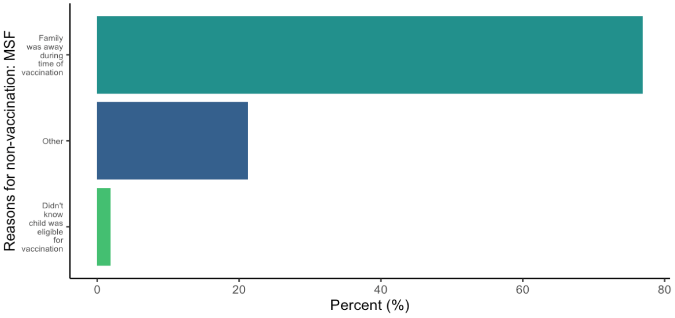

### Vaccination coverage – routine Vaccination (9 months)

Information on routine vaccination status (i.e. the routine vaccination normally administered at 9 months of age) was collected from 985 children aged 6 months to 9 years. Of those children, 45.4% (95% CI: 35.0–56.1) reported receiving a routine measles vaccination, either by showing their vaccination card or by verbal confirmation (Table #). Most of the affirmative responses were through verbal confirmation; the measles vaccination coverage among children who were able to show their vaccination card was 2.1% (95% CI 1.1–3.9).

Table 4. Measles vaccination coverage among children aged 6 months to 9 years during routine vaccination at 9 months in Béboto district, Logone Oriental province, Chad (weighted analysis)

| **Routine vaccination status** | **Children (n)** | **% (95% CI)** | **Design effect** |
| --- | --- | --- | --- |
| Yes | 405 | 45.4 (35.0--56.1) | 11.1 |
| No | 417 | 38.6 (29.5--48.6) | 9.5 |
| Don't know | 160 | 15.6 (9.3--25.0) | 11.1 |
| No answer | 3 | 0.4 (0.1--2.6) | 3.4 |

### Reasons for non-vaccination (routine)

Figure 2. Reasons for not receiving measles vaccination during the routine (9 months) vaccination in Béboto district (N=417) (weighted analysis)

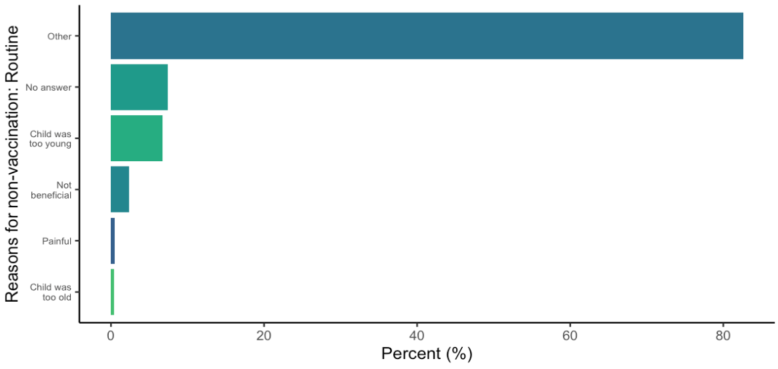

## Vaccination coverage – supplementary vaccination activities (SIA)

Information on supplementary vaccination activities (SIA) was collected from 985 children aged 6 months to 9 years. Of those children, 48.0% (95% CI: 38.3–56.1) reported receiving measles vaccination through previous SIA, either by showing their vaccination card or by verbal confirmation (Table #). Most of the affirmative responses were through verbal confirmation; the measles vaccination coverage among children who were able to show their vaccination card was 1.7% (95% CI 0.6–4.5).

Table 5. Measles vaccination coverage among children aged 6 months to 9 years during other vaccination opportunities in Béboto district, Logone Oriental province, Chad (weighted analysis)

| **SIA vaccination status** | **Children (n)** | **% (95% CI)** | **Design effect** |
| --- | --- | --- | --- |
| Yes | 478 | 48.0 (38.3--57.8) | 9.3 |
| No | 377 | 39.6 (33.8--45.7) | 3.6 |
| Don't know | 122 | 12.4 (7.1--20.8) | 9.7 |
| No answer | 8 | 1.1 (0.3—3.4) | 3.6 |

### Reasons for non-vaccination (SIA)

Figure 3. Reasons for not receiving measles vaccination during the SIA in Béboto district (N= 377) (weighted analysis)

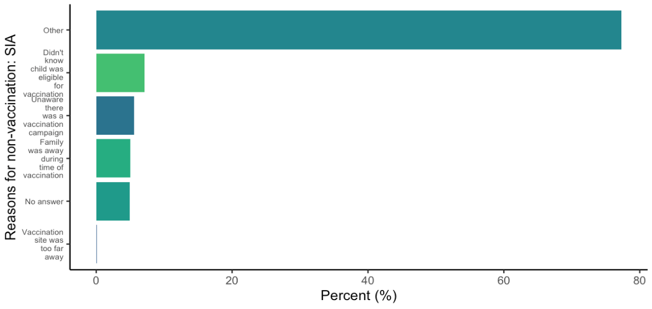

## overall measles vaccination coverage

To calculate overall measles vaccination coverage in Béboto district, all vaccination opportunities were taking into account for the 985 children aged 6 months to 9 years. Of those children, 98.1% (95% CI: 96.3–99.1) reported receiving vaccination in their lifetime, either by showing their vaccination card or by verbal confirmation (Table #).

Table 6. Overall measles vaccination coverage among children aged 6 months to 9 years in Béboto district, Logone Oriental province, Chad (weighted analysis)

| **Overall vaccination status** | **Children (n)** | **Vaccination coverage (95% CI)** | **Design effect** |
| --- | --- | --- | --- |
| Vaccinated | 964 | 98.1% (96.3--99.1) | 2.2 |
| Not vaccinated | 21 | 1.9% (0.9--3.7) | 2.2 |

Figure # presents the vaccination coverage among children aged 6 months to 9 years by the different vaccination opportunities, and the overall vaccination coverage for measles in the 13 health zones where the MSF vaccination campaign and coverage survey took place.

Figure 4. Measles coverage by vaccination opportunity among children aged 6 months to 9 years in Béboto district, Logone Oriental province, Chad (weighted analysis)

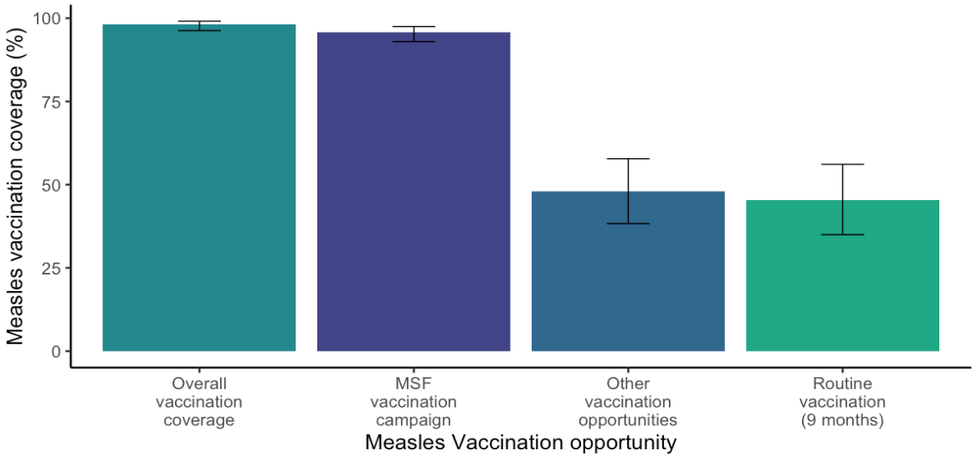

## Previous measles diagnosis

Information on previous measles diagnosis (as reported by caretaker) was collected from 985 children aged 6 months to 9 years. Of those children, 21.5% (95% CI: 16.4–27.6) reported previously having measles.

Of the children who reported previously having measles, the median age the child became ill was 4 years. However, 747 (75.8%) individuals were missing information on age in this category.

Table 7. Previous measles diagnosis among children aged 6 months to 9 years in Béboto district, Logone Oriental province, Chad (weighted analysis)

| **Previous measles diagnosis** | **Children (n)** | **Percent (95% CI)** | **Design effect** |
| --- | --- | --- | --- |
| Yes | 238 | 21.5% (16.4--27.6) | 4.4 |
| No | 718 | 75.5% (70.4--80.0) | 3.0 |
| Don’t know | 29 | 3.0% (1.3--6.6) | 4.8 |

Based on overall vaccination history and previous measles diagnosis (as reported by the caretaker), the estimated immunity in children aged 6 months to 9 years is 98.7% (95% CI: 97.5–99.4).

Table 8. Immune status among children aged 6 months to 9 years in Béboto district, Logone Oriental province, Chad (weighted analysis)

| **Immune status** | **Children (n)** | **Immunity (95% CI)** | **Design effect** |
| --- | --- | --- | --- |
| Immune | 971 | 98.7% (97.5--99.4) | 1.4 |
| Susceptible | 14 | 1.3% (0.6--2.5) | 1.4 |